Afeef Akhtar
Project 2 Report
Umer Cheema
I have derived the graph using the table and implemented the Moore Design based on my graph derivation. This attachment shows all the work I have done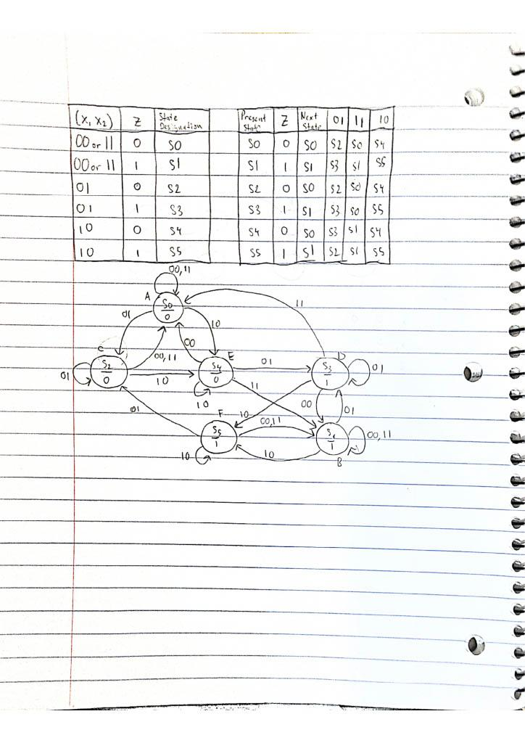

Given the way I have derived it, I have implemented my derivations into quartus using case methods for the inputs and outputs. My Moore and RTL schematic ended up looking as follows:
